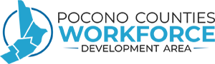
Workforce Development Board Meeting
June 1, 2022
Agenda
- Call to Order
- Review of Minutes – WDB Meeting March 2, 2022*
- Financial Report – Susan Rhoads-Procina, Fiscal Manager
- Operations/UC Update
- Local Monitor Report – Ben Winn, Deputy Director
- Bylaw Change Results and State Monitoring Update
- WDB Board Vacancies
- RFP Approvals*
  - Monroe County Innovative In-School Youth Program
  - Monroe County Youth Offender Re-Entry Program
  - Carbon County Youth Offender Re-Entry Program
- RFP Requests*
- Youth Work Experience Wage Increase*
- CareerLink Reports
- Public Comments
- Other Business
- Adjournment*

