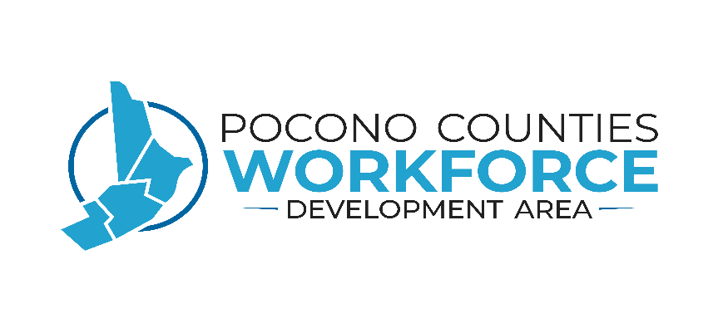
POCONO COUNTIES
WORKFORCE DEVELOPMENT BOARD (WDB)/AREA (NE 135)
Non-Discrimination & equal opportunity compliance policy
- Purpose

The purpose of this policy is to comply with the provisions in Section 188 of the Workforce Innovation and Opportunity Act (WIOA) and the Department of Labor’s regulations, 29CFR Part 37.
Section 188 of WIOA prohibits discrimination on the basis of race, color, religion, sex, national origin, age, disability, political affiliation or belief in both participation and employment: and against any beneficiary of programs financially assisted under Title I of the Workforce Innovation and Opportunity Act (WIOA), on the basis of the beneficiary’s citizenship/status as a lawfully admitted immigrant authorized to work in the United States, or his or her participation in any WIOA Title I-financially assisted program or activity. The nondiscrimination regulations of WIOA prohibit discrimination in all aspects of the administration, management and operation of WIOA Title I financially assisted programs or activities.

- Effective Date:
7/1/20

- Implementation

The WIOA Title I funded program provider may not:
- Deny an individual an opportunity to access any aid, benefits, services, or training;
- Provide to an individual any aid, benefits, services, or training that is different, or is provided in a different manner, from that provided to others;
- Subject an individual to segregation or separate treatment in any matter related to his or her receipt of any aid, benefits, services, or training;
- Restrict an individual in any way in the enjoyment of any advantage or privilege enjoyed by others receiving any aid, benefit, service, or training;
- Treat an individual differently from others in determining whether he or she satisfies any admission, enrollment, eligibility, membership, or other requirement or condition for any aid, benefit, service, or training provided;
- Deny or limit an individual with respect to any opportunity to participate in a WIOA Title I funded program or activity, or afford him or her an opportunity to do so that is different from an opportunity afforded others;
- Deny an individual the opportunity to participate as a member of a planning or advisory body that is an integral part of the WIOA Title I funded program or activity;
- Otherwise limit on a prohibited ground an individual in enjoyment of any right, privilege, advantage, or opportunity enjoyed by others receiving any WIOA I financially assisted aid, benefits, services, or training.

Recipients of WIOA Title I financially assisted programs include:
- State level agencies that administer, or are financed in whole or in part, with WIOA Title I funds:
- State Employment Security Agencies;
- State and Local Workforce Investment Boards;
- LWIA Grant Recipients;
- One Stop Operators;
- Service providers, including eligible training providers;
- On the Job Training (OJT) Employers;
- Job Corps Contractors and Center Operators, excluding the operators of federally operated Job Corps Centers;
- Job Corps national training contractors;
- Outreach and admissions agencies, including Job Corps contractors that perform these functions;
- Placement agencies, including Job Corps contractors that perform these functions; and
- One Stop Partners, to the extent that they participate in the One Stop System.

Complaints may be filed by:
- Applicants/registrants for aid, benefits, services or training
- Eligible applicants/registrants
- Participants
- Employees
- Applicants for employment
- Eligible service providers

4. Nondiscrimination & Equal Opportunity Policy Elements

A. Pocono Counties WDA Equal Opportunity (EO) Officer and PA CareerLink® and Affiliate Site EO Liaisons

Pocono Counties WDA EO Officer

Benjamin Winn, Deputy Director
811 Blakeslee Boulevard Drive East, Suite 85
Lehighton, PA 18235
(484) 464-2494
bwinn@ptd.net

EO Officer Responsibilities/Duties

1. Conduct monitoring reviews of the Pocono Counties CareerLink®, Affiliate Sites, Subcontracted Grant recipients and service providers as designated in the Pocono Counties Monitoring Policy to ensure compliance with applicable Equal Opportunity/Americans with Disabilities Act (EO/ADA) laws.

2. Communicate with and coordinate activities with the Equal Opportunity Specialists from the Office of Equal Opportunity (OEO) on matters involving EO/ADA compliance.

3. Handles inquiries regarding EO complaints, investigates complaints, and works to resolve EO complaints informally, and/or refers unresolved complaints to the Equal Opportunity Specialist at the Office of Equal Opportunity as described in the Pocono Counties EO Complaint Procedure. Provides complainants with the proper forms and assistance in the proper completion and submission to the Office of Equal Opportunity. Maintains Complaint logs and other related records of complaints and resolutions of EO/ADA issues.

4. Reviews and submits Training Logs annually to the OEO documenting the PA CareerLink® and Affiliate Site staff training on general topics of Civil Rights, Disability Sensitivity, Workplace Diversity and other related EO/ADA topics.

5. Assists with State Employment Security Agency (SESA) Compliance Reviews.

Pocono Counties CareerLink® and Affiliate Site EO Liaisons

Carbon County CareerLink®
Lisa Price, BWPO Supervisor
50 E Locust Street
Nesquehoning, PA 18240
(570) 325-2701 ext. 112
liprice@pa.gov

Monroe County CareerLink®
Pamela Joseph, BWPO Supervisor
2937 Route 611, Merchants Plaza
Tannersville, PA 18372
(570) 620-2853
pamjoseph@pa.gov

Pike County Workforce Development
Cynthia DeFebo, Director
837 Route 6, Unit 2
Shohola, PA 18458
(570) 296-2909
cdefebo@pikepa.org

Wayne Workforce Development
Helene Mancuso, Director
650 1/2 W Park St.
Honesdale, PA 18437
570-229-3420
hmancuso@wpworkforce.org

EO Liaisons Responsibilities/Duties

1. Monitor and ensure that the site is in compliance with applicable Equal Opportunity/Americans with Disabilities Act (EO/ADA) laws.

2. Communicate with and coordinate activities with the Pocono Counties EO Officer on matters involving EO/ADA compliance.

3. Provide training and instruction to staff regarding EO/ADA compliance responsibilities. Maintains Training logs to document EO/ADA related staff training activities.

4. Handles inquiries regarding EO complaints, investigates complaints, and works to resolve EO complaints informally, and/or refers unresolved complaints to the Pocono Counties EO Officer as described in the Pocono Counties EO Complaint Procedure. Provides complainants with the proper forms and assistance in the proper completion and submission to the EO Officer. Maintains local Complaint logs and other related records of complaints and resolutions of EO/ADA issues. Notifies EO officer of all complaints upon receipt.

5. Assists during State Employment Security Agency (SESA) Compliance reviews.

B. Notice and Communications

1. In accordance with the provisions of the Pocono Counties WDA Non-discrimination and Equal Opportunity Policy, all CareerLink® and Affiliate sites will post the Equal Opportunity Posters, in English and Spanish, in their respective public reception areas, and in common rooms utilized by partner staff in the sites. Also posted are similar versions of the Equal Opportunity Posters which include the name and contact information for the Pocono Counties EO Officer. The posters are listed below.

2. All materials made available to the public at the Pocono Counties CareerLink® and affiliate sites must include the following language:
“Auxiliary aids and services are available upon request to individuals with disabilities.”
“Equal Opportunity Employer/Program”

This information must also be included in any brochures, advertisements, websites, or other public documents regarding services provided at any service site.

3. All PA CareerLink® and affiliate site partner staff will be made aware of this information and their responsibilities regarding the Pocono Counties Non-Discrimination and Equal Opportunity Policy at the time of orientation or through staff development and training procedures.

4. PA CareerLink® and affiliate sites will also have plans, procedures, and resources in place to address the needs of customers with Limited English Proficiency (LEP), or the needs of customers requesting auxiliary aids in accessing or participating in services provided by the service location.

5. Customers applying for Title I Services will also be provided copies of the Civil Rights Statement, and the Pocono Counties WDA Grievance and Complaint Procedure at the time of application. The Title I Service Provider will maintain a signed Civil Rights Receipt in the customer’s file to verify that the customer received this information at the time of application. The forms are listed below.

C. EO and Nondiscrimination Assurances in Plans, Contracts, and Agreements

1. The Pocono Counties WDA includes assurances and certifications in their Strategic, Local, and Regional Plans that they will comply with the provisions in Section 188 of the Workforce Innovation and Opportunity Act (WIOA) and the Department of Labor’s regulations, 29CFR Part 37. This includes assurances that all service providers supported by the Pocono Counties WDA will comply with all applicable Equal Opportunity (EO), Civil Rights, and Americans with Disabilities Act (ADA) regulations in the provision of their services.

2. Language regarding service provider Equal Opportunity and Americans with Disability Act compliance requirements is included in the following agreements utilized by the Pocono Counties WDA.
- All Contracts with Title I Service Providers or for other services procured through the Pocono Counties Request for Proposal Process.
- All PA CareerLink® Operator or MOU (Memorandum of Understanding) Agreements for PA CareerLinks®.
- All Non-Financial Agreements with Eligible Training Providers utilized for ITA or Apprenticeship Services.
- All OJT, Incumbent Worker, Transitional Employment, or worksite agreements participating in Work Experience or Internship services supported by the Pocono Counties WDA.

